**ELI SAMUEL MAZARIEGOS RAMIREZ 201709426 HT2**

1. **MEDIANTE EL MÉTODO DEL ÁRBOL, OBTENGA EL AFD EL CUAL IMPLEMENTARÁ EN CÓDIGO PARA EL DESARROLLO DE LA FASE DE SU ANÁLISIS LÉXICO EN SU PROYECTO.**

**1.1 ER [(A-Z) | (a-z)] . [(A-Z) |(a-z) |(0-9)]* | [(0-9) . (0-9)*] |[<] | [>] | [‘] | [/] | [.] | |[,] | [!]**

1.2 ARBOL

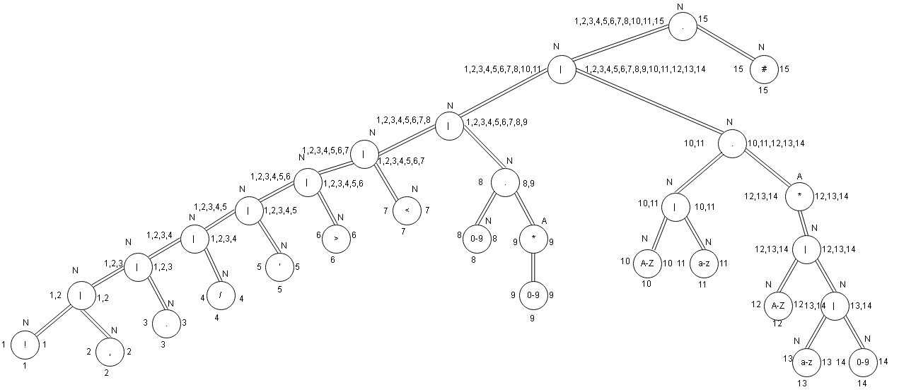

* 1. **TABLA DE SIGUIENTES**

|  |  |
| --- | --- |
| HOJA | Follow post |
| 1 | 15 |
| 2 | 15 |
| 3 | 15 |
| 4 | 15 |
| 5 | 15 |
| 6 | 15 |
| 7 | 15 |
| 8 | 8,9,15 |
| 9 | 8,9,15 |
| 10 | 10,11,12,13,14,15 |
| 11 | 10,11,12,13,14,15 |
| 12 | 10,11,12,13,14,15 |
| 13 | 10,11,12,13,14,15 |
| 14 | 10,11,12,13,14,15 |
| 15 | - |

**1.4 TABLA DE TRANSICIONES**

|  |  |  |  |  |  |  |  |  |  |  |
| --- | --- | --- | --- | --- | --- | --- | --- | --- | --- | --- |
| ESTADO | ! | , | . | / | ' | > | < | 0-9 | A-Z | a-z |
| So = {1} | A = 15 |  |  |  |  |  |  |  |  |  |
| So = {2} |  | B = 15 |  |  |  |  |  |  |  |  |
| So = {3} |  |  | C = 15 |  |  |  |  |  |  |  |
| So = {4} |  |  |  | D = 15 |  |  |  |  |  |  |
| So = {5} |  |  |  |  | E = 15 |  |  |  |  |  |
| So = {6} |  |  |  |  |  | F = 15 |  |  |  |  |
| So = {7} |  |  |  |  |  |  | G = 15 |  |  |  |
| So = {8} |  |  |  |  |  |  |  | H = 8,9,15 |  |  |
| H = {8} |  |  |  |  |  |  |  | H |  |  |
| So = {9} |  |  |  |  |  |  |  | H |  |  |
| H = {9} |  |  |  |  |  |  |  | H |  |  |
| So = {10} |  |  |  |  |  |  |  |  | I =  10,11,12,13,14,15 |  |
| I ={10,..14} |  |  |  |  |  |  |  | I | I | I |
| So = {11} |  |  |  |  |  |  |  |  |  | I |
|  |  |  |  |  |  |  |  |  |  |  |
|  |  |  |  |  |  |  |  |  |  |  |
|  |  |  |  |  |  |  |  |  |  |  |
|  |  |  |  |  |  |  |  |  |  |  |
|  |  |  |  |  |  |  |  |  |  |  |
|  |  |  |  |  |  |  |  |  |  |  |
|  |  |  |  |  |  |  |  |  |  |  |
|  |  |  |  |  |  |  |  |  |  |  |

**1.5 AFD**

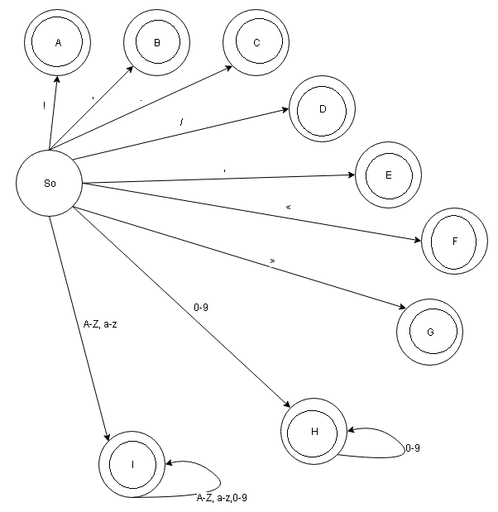

1. **ESCRIBA UNA GRAMÁTICA DE TIPO 2 SEGÚN LA JERARQUÍA DE CHOMSKY O TAMBIÉN CONOCIDA COMO GRAMÁTICA INDEPENDIENTE DEL CONTEXTO EL CUAL IMPLEMENTARÁ EN CÓDIGO PARA EL DESARROLLO DE LA FASE DE SU ANÁLISIS SINTÁCTICO EN SU PROYECTO.**

|  |  |
| --- | --- |
| So **→** | T T |
| T T **→** | T T T |
| T **→** | <ID>INNER</ID> |
|  | **|** <ID>TT</ID> |
| INNER **→** | INNEN IN |
|  | **|** IN |
| IN **→** | ID | ! | ' | NUM |